A Project on Predicting Personal Loan Approval using

Machine Learning

Submitted in partial fulfilment of requirement for the award of degree of

bachelor of science

in

Computer Science

Submitted By

1. Sankar Sri Kannan M
2. Ramesh V
3. Vinoth G
4. Akash J

Under the supervision of

Dr.Vijayalatha



**DEPARTMENT OF COMPUTER SCIENCE**

**GOVERNMENT ARTS AND SCIENCE COLLEGE**

**KOVILPATTI**

**PREDICTING PERSONAL LOAN APPROVAL USING MACHINE LEARNING**

**1. INTRODUCTION:**

**1.1 OVERVIEW:**

* **Predicting loan personal loan approval using machine learning is a project aimed at developing a model that can predict whether an individual is likely to be approved or denied for a personal loan based on various factors such as their credit score, income, employment status, debt-to-income ratio, and other relevant information.**
* **The project involves using machine learning algorithms such as logistic regression, decision trees, random forests, and support vector machines to train a model on a dataset containing historical loan application data, including both approved and denied applications. The model is then tested on a separate set of data to evaluate its accuracy and determine its ability to predict loan approval outcomes for new loan applications.**
* **To develop an accurate machine learning model for predicting personal loan approval, collecting relevant data on loan applicants is crucial. Personal information, such as age, gender, marital status, and education level, can provide insights into a borrower's background and potentially affect their ability to repay the loan. Financial data, such as credit score, income, and employment status, are particularly important as they provide an indication of a borrower's financial health and repayment capacity. It is also essential to ensure that the data collected is accurate and up-to-date to avoid biases and errors in the predictive model.**
* **The ultimate goal of developing a predictive model for personal loan approval using machine learning is to help financial institutions and lenders automate the loan approval process, reduce the risk of default, and improve operational efficiency. By leveraging machine learning algorithms, lenders can analyze large amounts of data and identify patterns that are not easily visible to humans**

**1.2 PURPOSE:**

* **Improving the loan approval process: By predicting loan approval outcomes using machine learning, lenders can automate much of the loan approval process, reducing the time it takes to make a decision and improving operational efficiency. This can be particularly beneficial for lenders who receive a large volume of loan applications on a daily basis, as it can help them streamline their operations and process applications more quickly.**
* **Providing more accurate loan approval decisions: Machine learning algorithms can analyze large amounts of data to identify patterns and make predictions with high accuracy. By using machine learning to predict loan approval outcomes, lenders can make more informed decisions and reduce the risk of errors and biases. This can lead to more accurate loan approval decisions that are based on objective data rather than subjective judgment.**
* **Reducing the risk of loan defaults: By identifying high-risk loan applications that are more likely to default, lenders can make informed decisions about whether to approve or deny a loan. This can help lenders reduce the risk of loan defaults and improve overall risk management. Additionally, by improving risk management practices, lenders may be able to offer more competitive loan terms to borrowers.**
* **Improving customer satisfaction: Faster and more efficient loan approval processes can lead to increased customer satisfaction. Borrowers who receive a quick decision on their loan application are more likely to have a positive experience and be more likely to use that lender again in the future. By using machine learning to automate the loan approval process, lenders can provide borrowers with a modern, streamlined experience that meets their expectations.**
* **Providing better insights into loan portfolios: By leveraging data and analytics to make more informed decisions, lenders can gain a deeper understanding of their loan portfolios. This can help lenders identify new business opportunities, improve marketing strategies, and make more informed decisions about business growth. Additionally, by having a better understanding of loan portfolios, lenders can develop more effective risk management strategies and reduce the risk of loan defaults.**

**2. PROBLEM DEFINITION & DESIGN THINKING:**

**2.1 Empathy Map:**

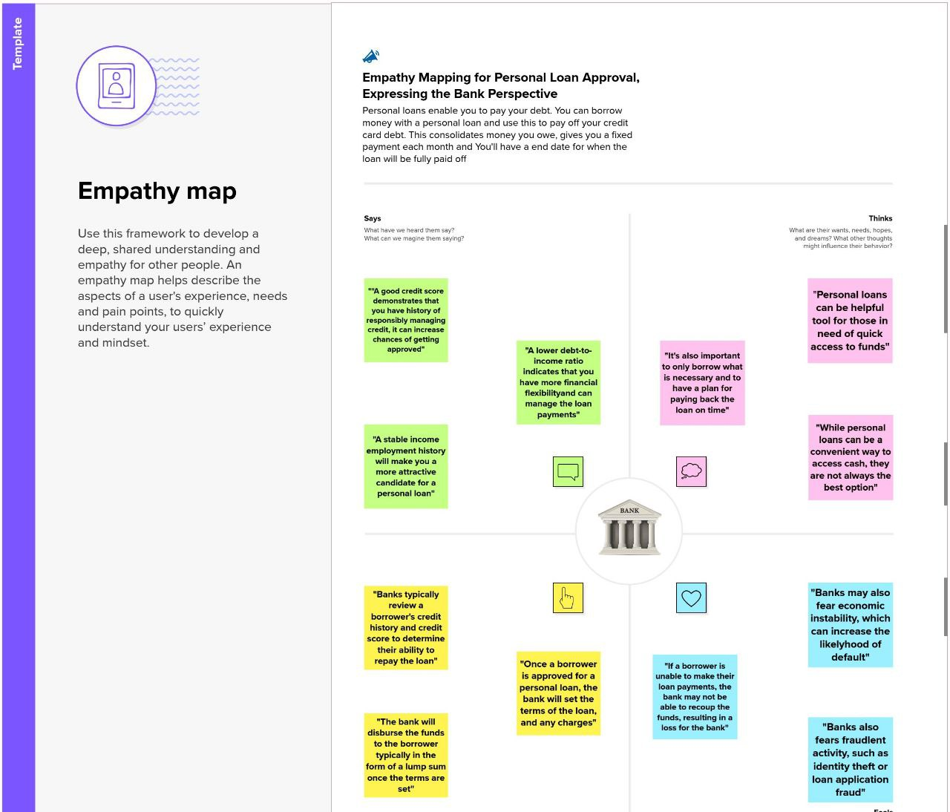

**2.2. Ideation & Brainstorming map:**

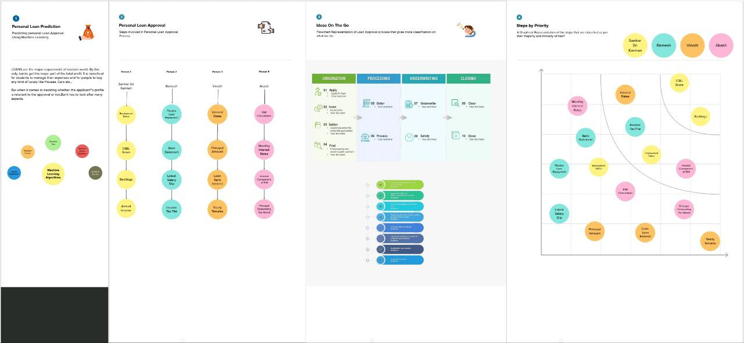

**3. RESULT:**

**3.1Data Model:**

|  |  |
| --- | --- |
| **Object name** | **Fields in the Object** |
| **Prediction** | |  |  | | --- | --- | | **Field label** | **Data type** | | Applicant Income | Integer | | Gender | Object | |
| **Logistic Regression** | |  |  | | --- | --- | | **Field label** | **Data type** | | Accuracy | Float | |  |  | |

**3.2 Activity & Screenshot**

**Importing libraries:**

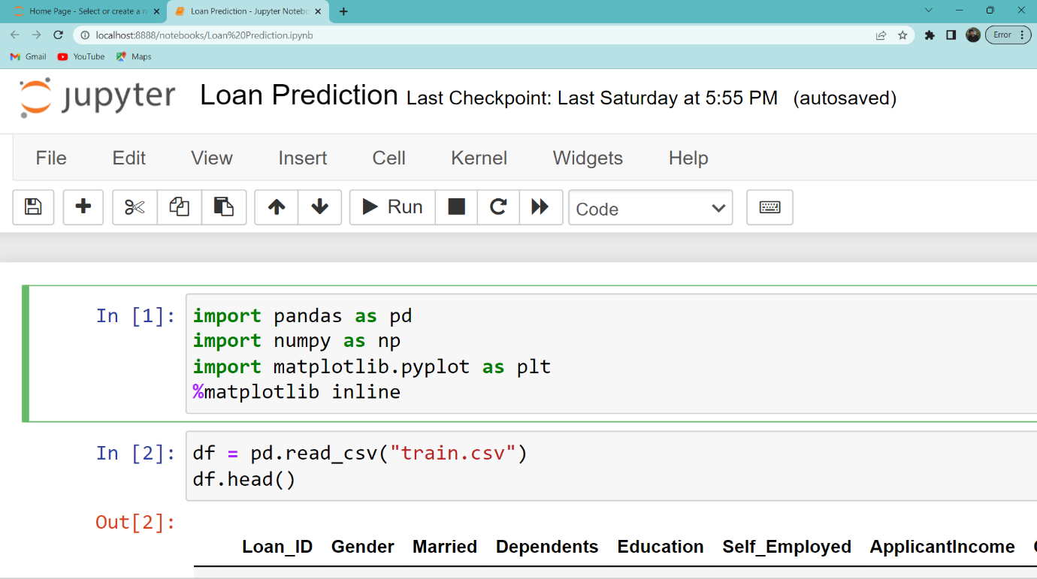

**Reading the dataset:**

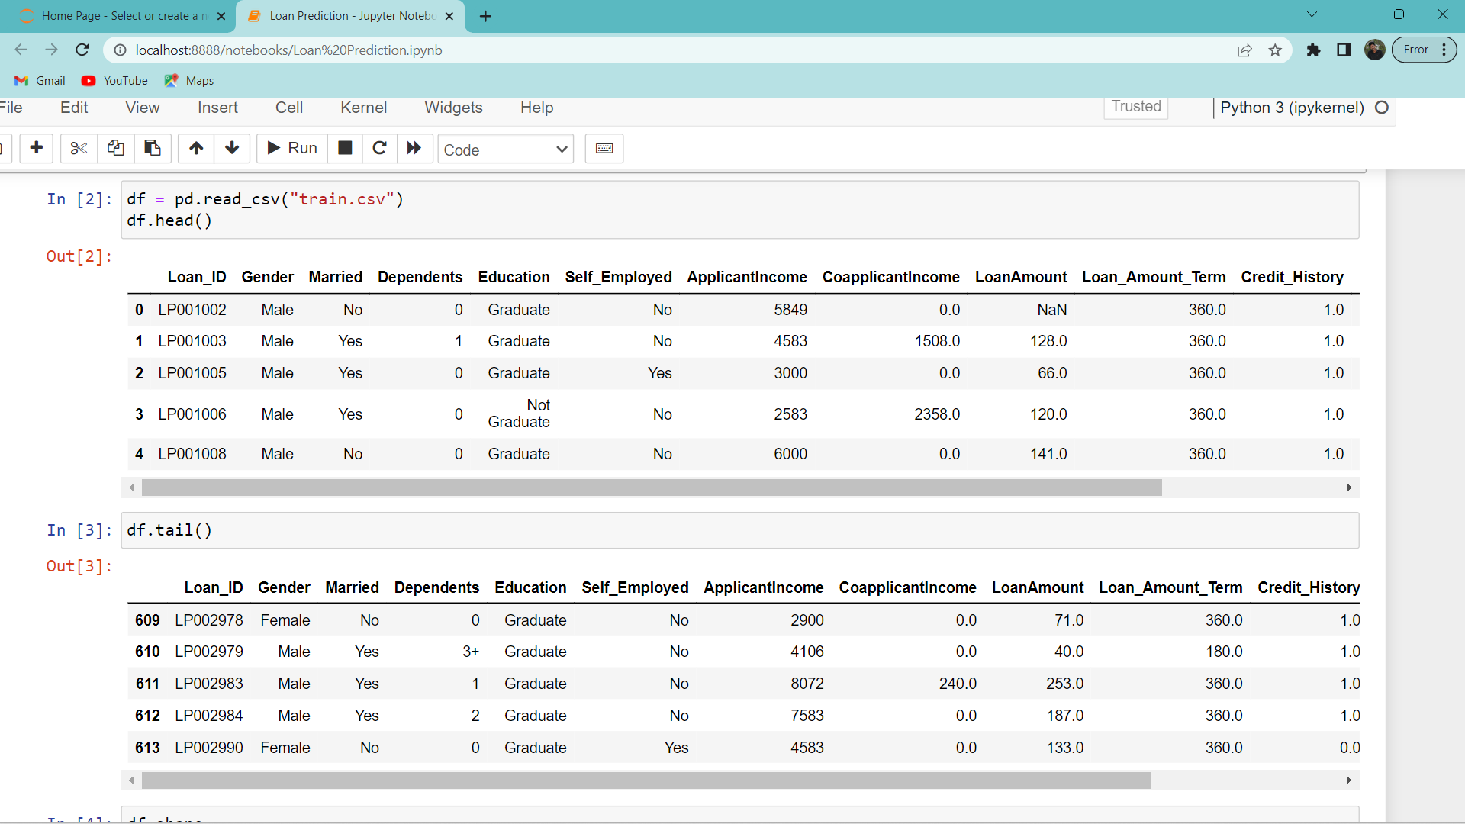

**Handling Missing data:**

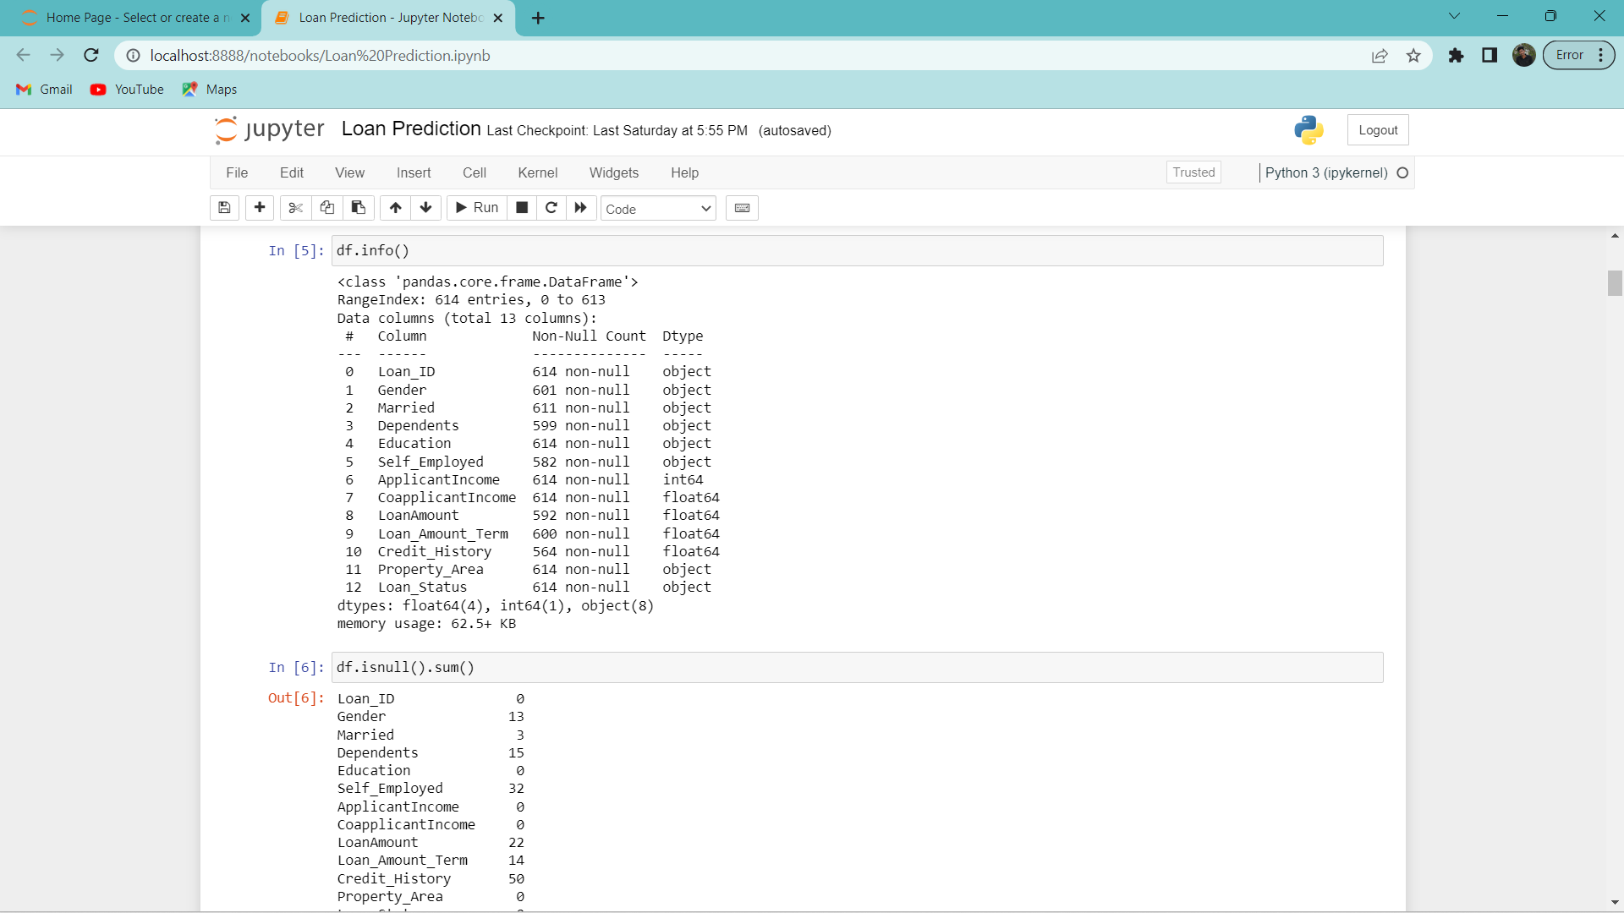

**Checking for Null values:**

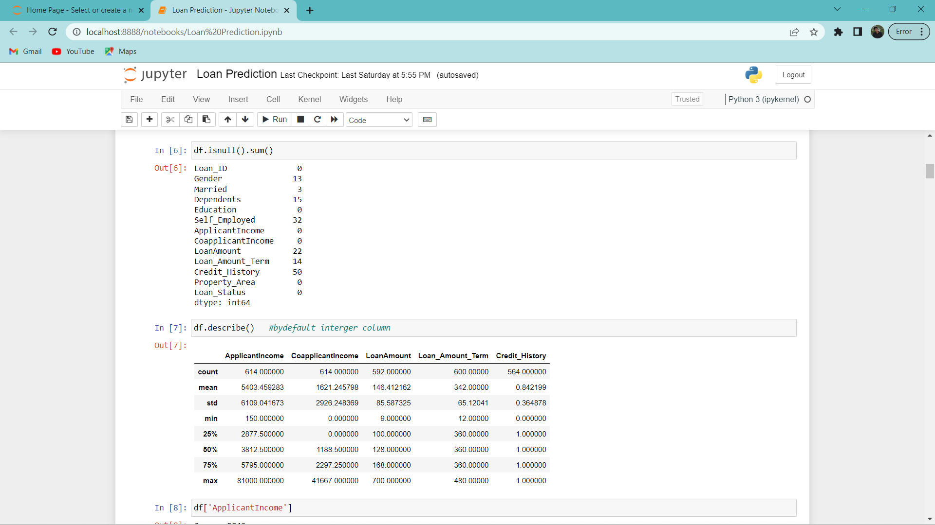

**Handling Missing Values:**

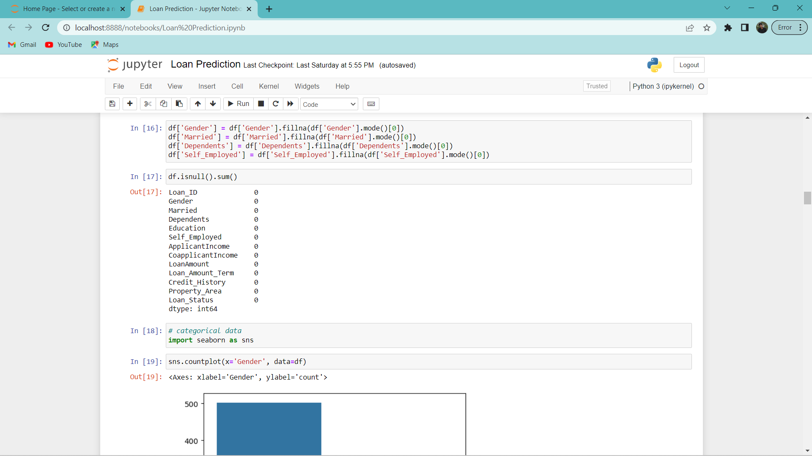

**Numerical datas:**

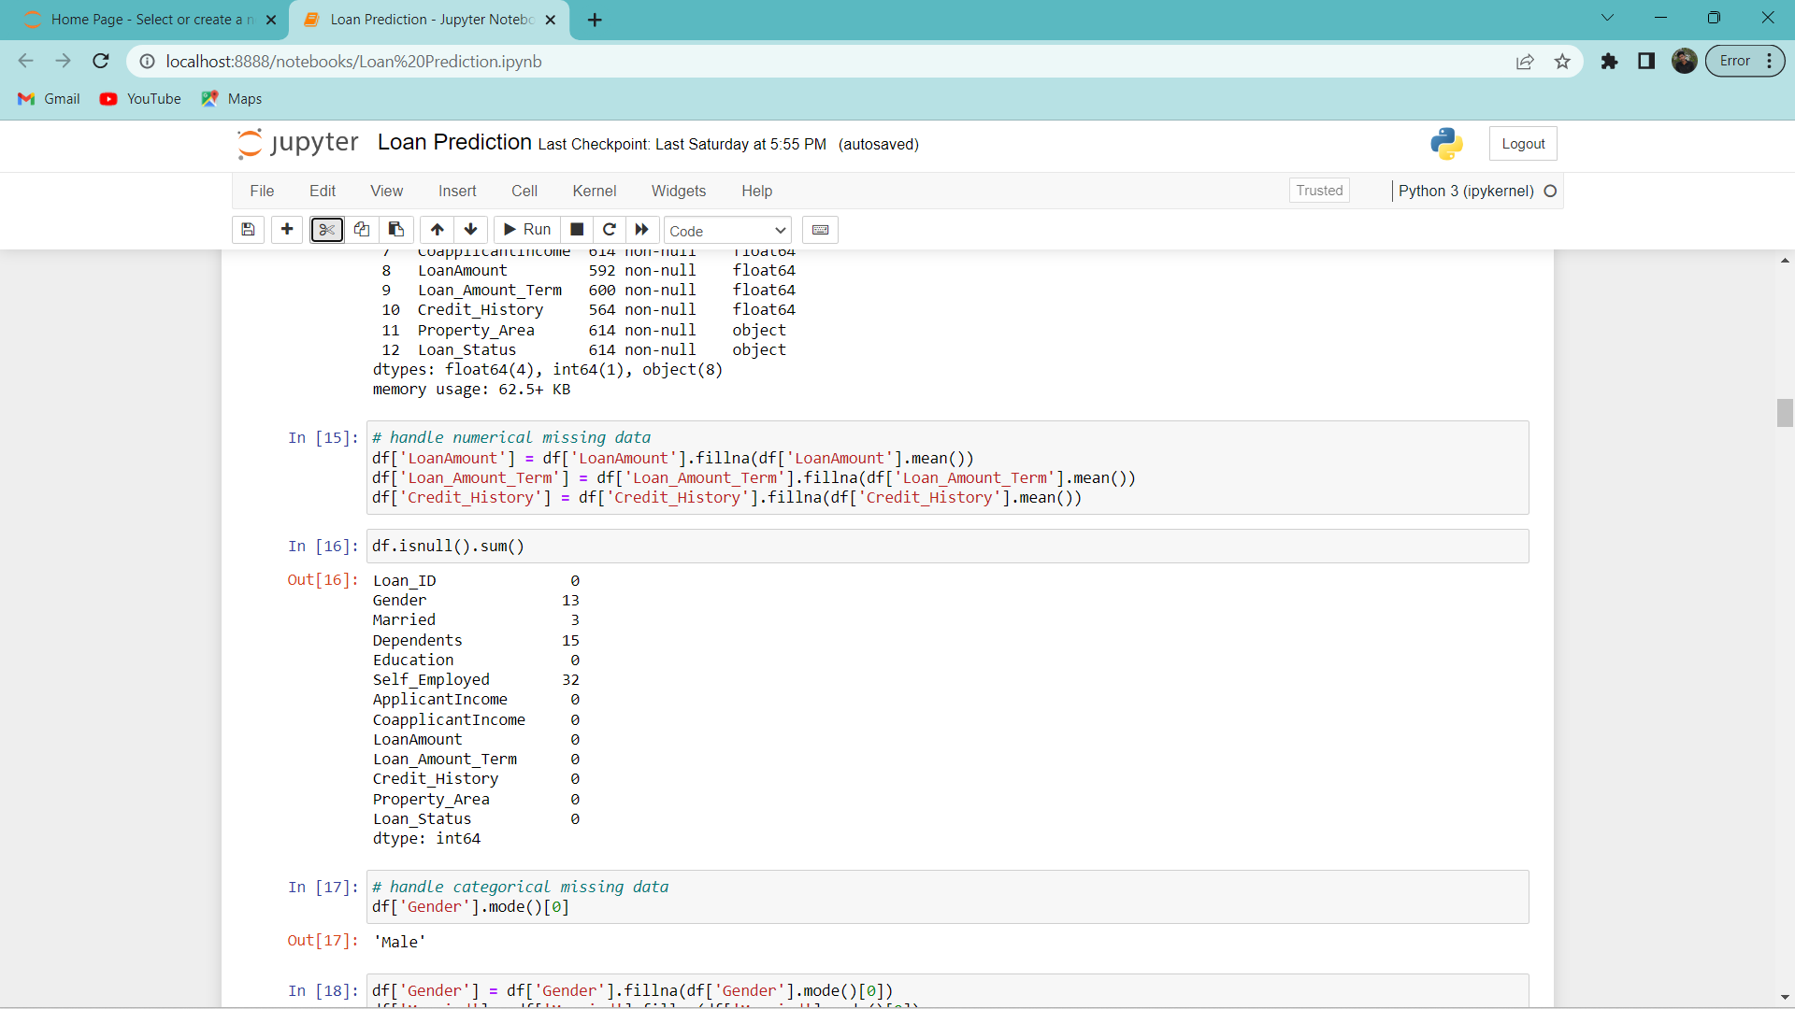

**Exploratory data analysis:**

**Descriptive Statistical:**

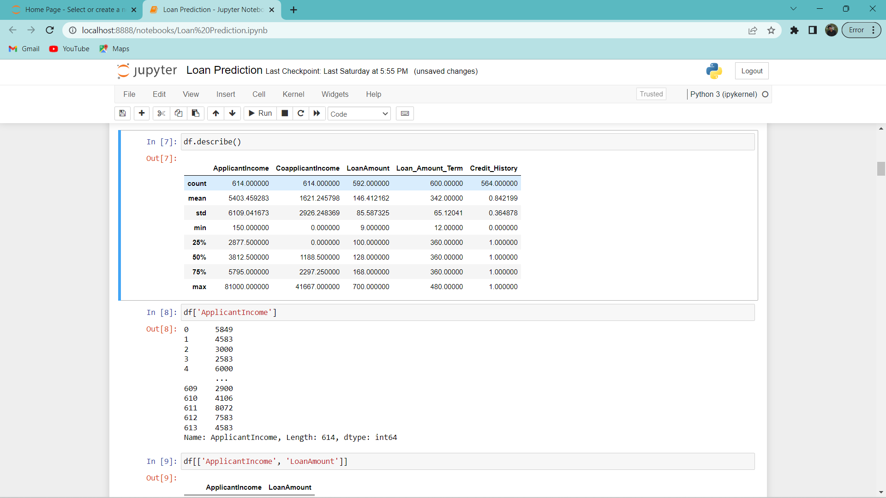

**Bivariate analysis:**

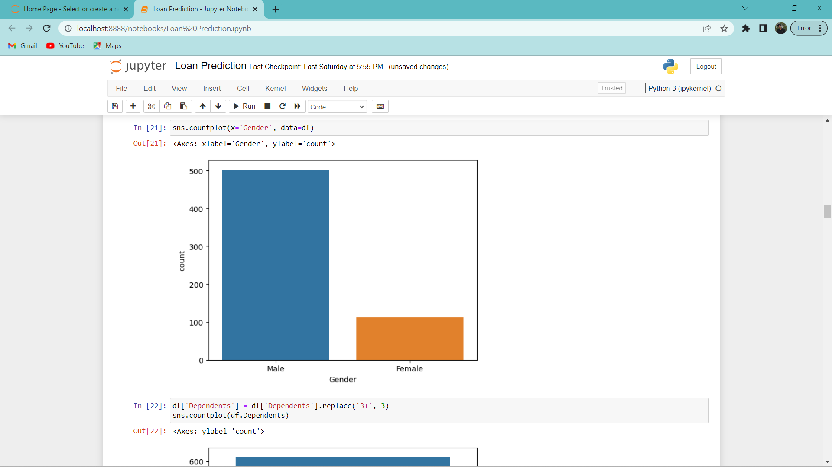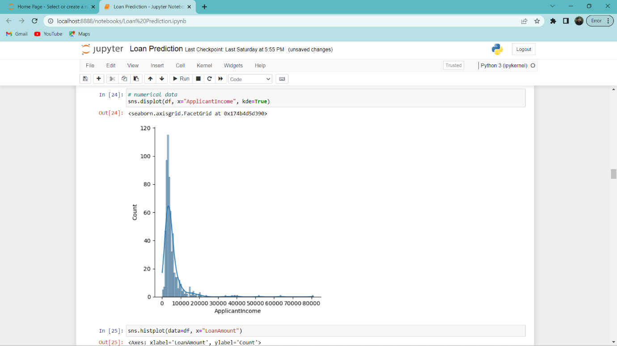

**Testing dataset:**

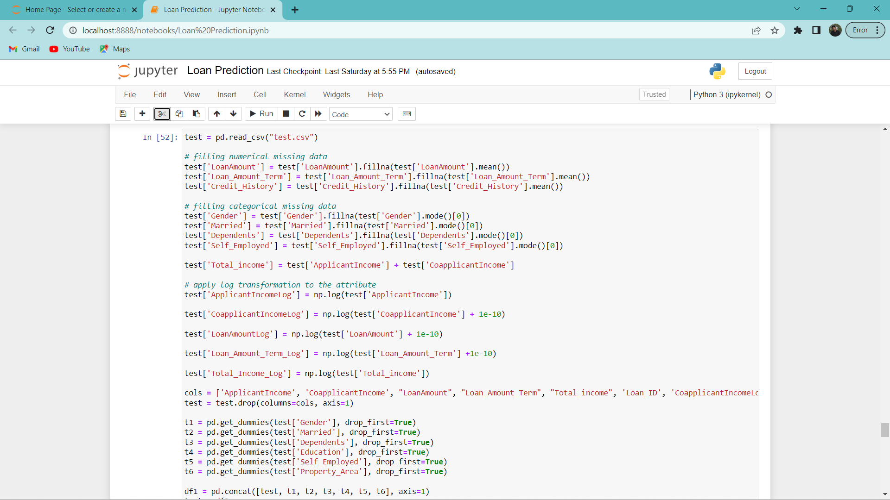

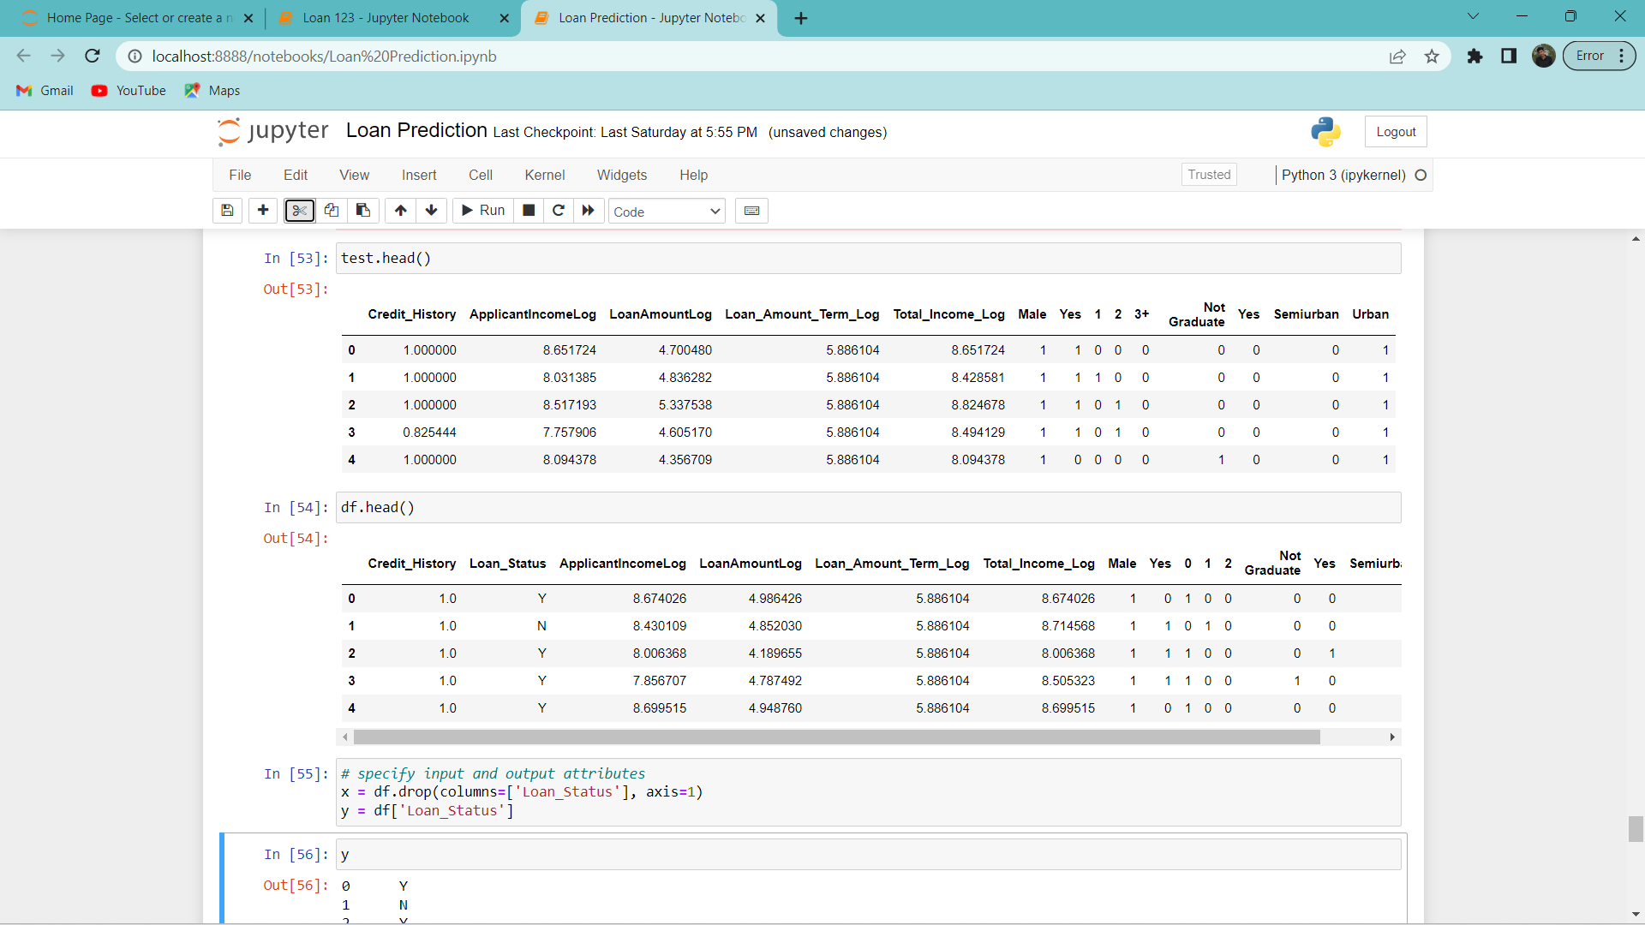

**Model training:**

**Random forest Model:**

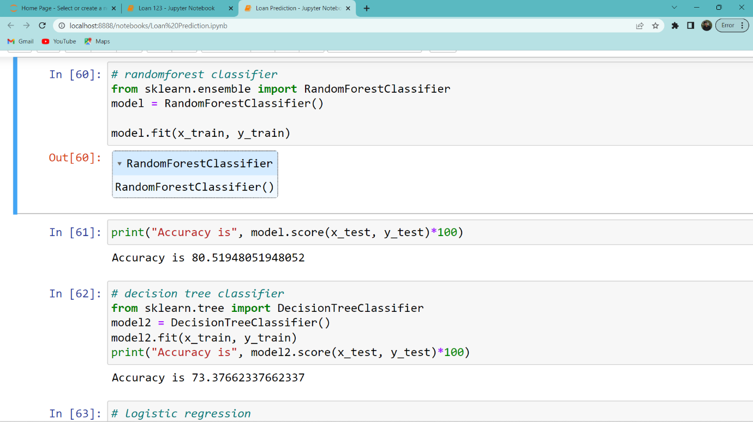

**Decision Tree Classifier:**

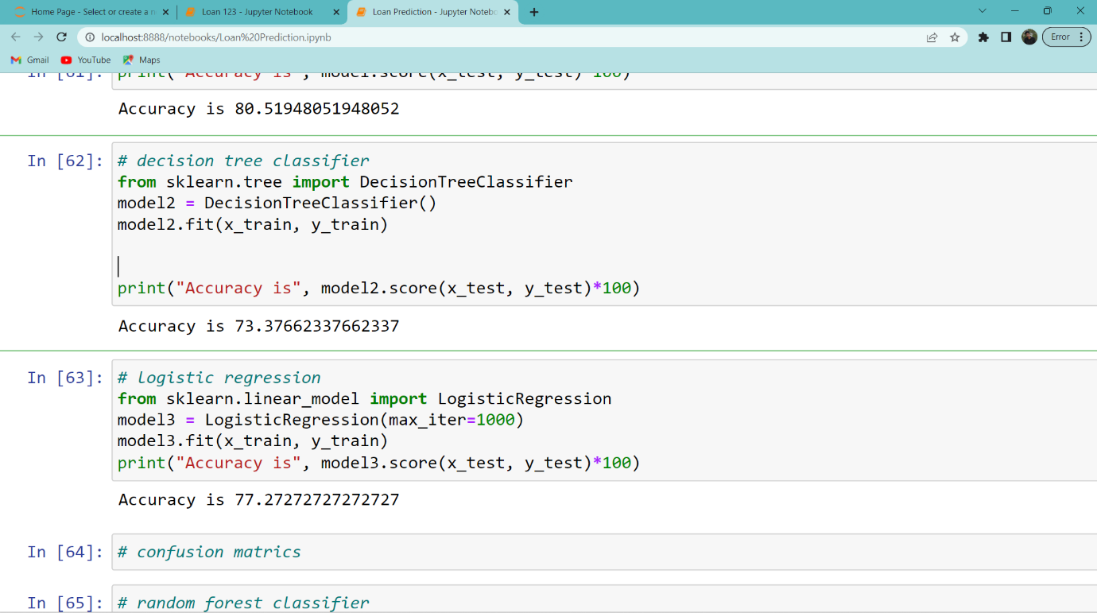

**Logistic Regression:**

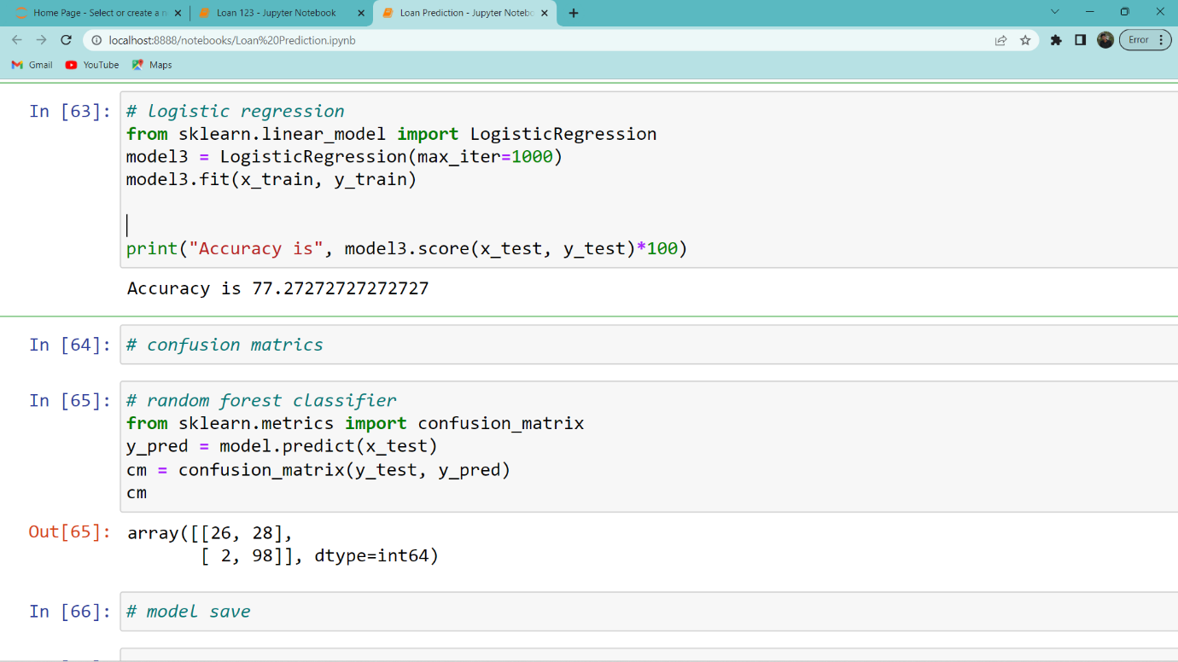

**Saving the model:**



**DEPLOYMENT:**

**Integrate with Web Framework**

* **Building HTML Pages**
* **Building Server Script**
* **Running the web application**

**Server Script**

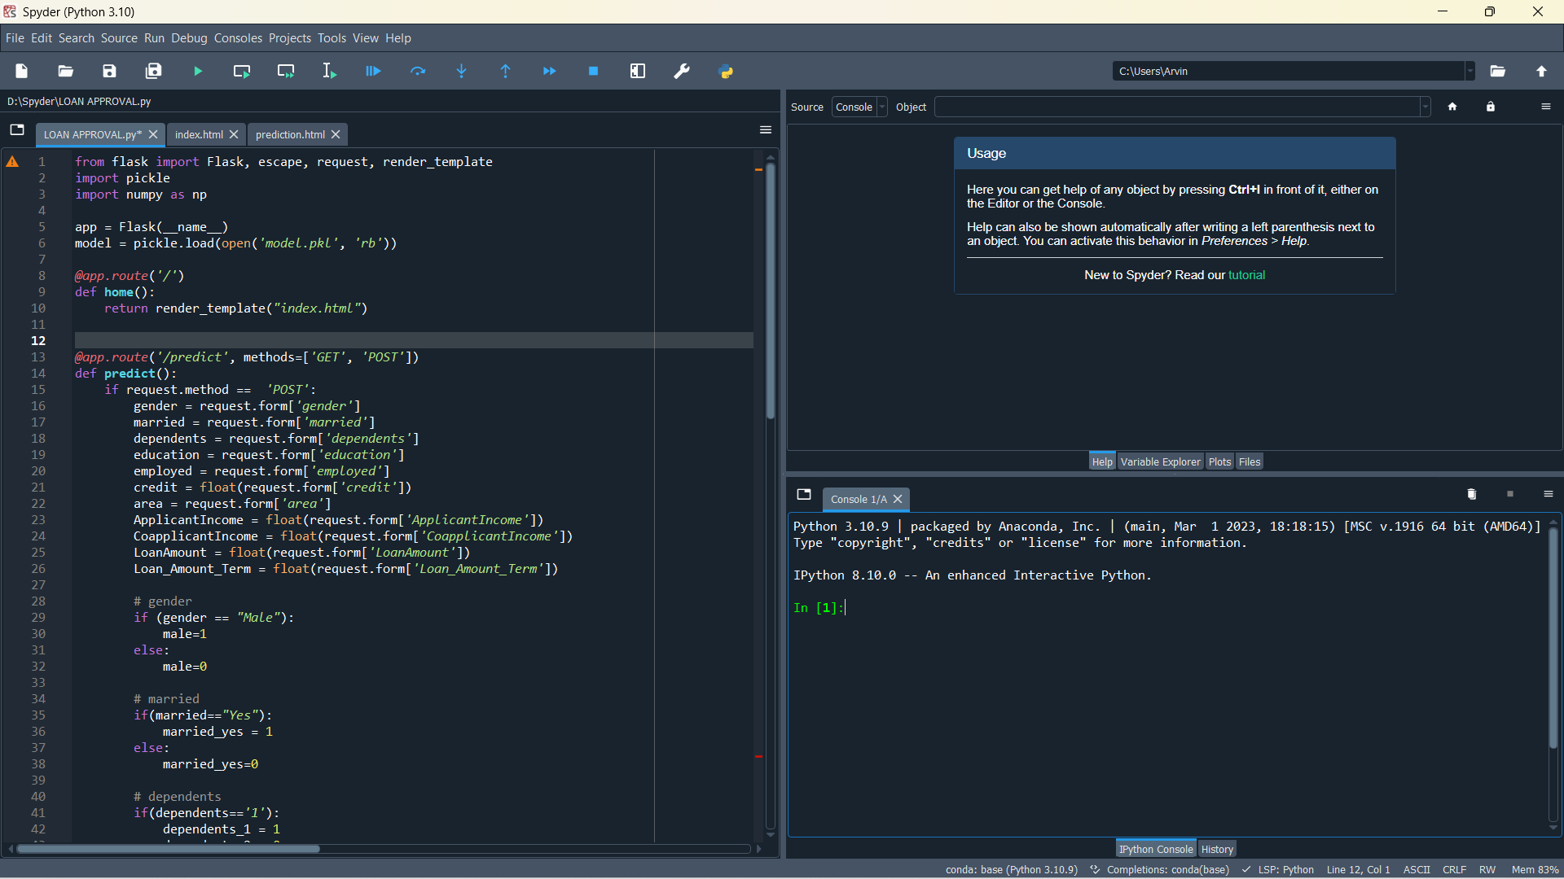

**HTML Pages**

1. **Index.html**
2. **Prediction.html**

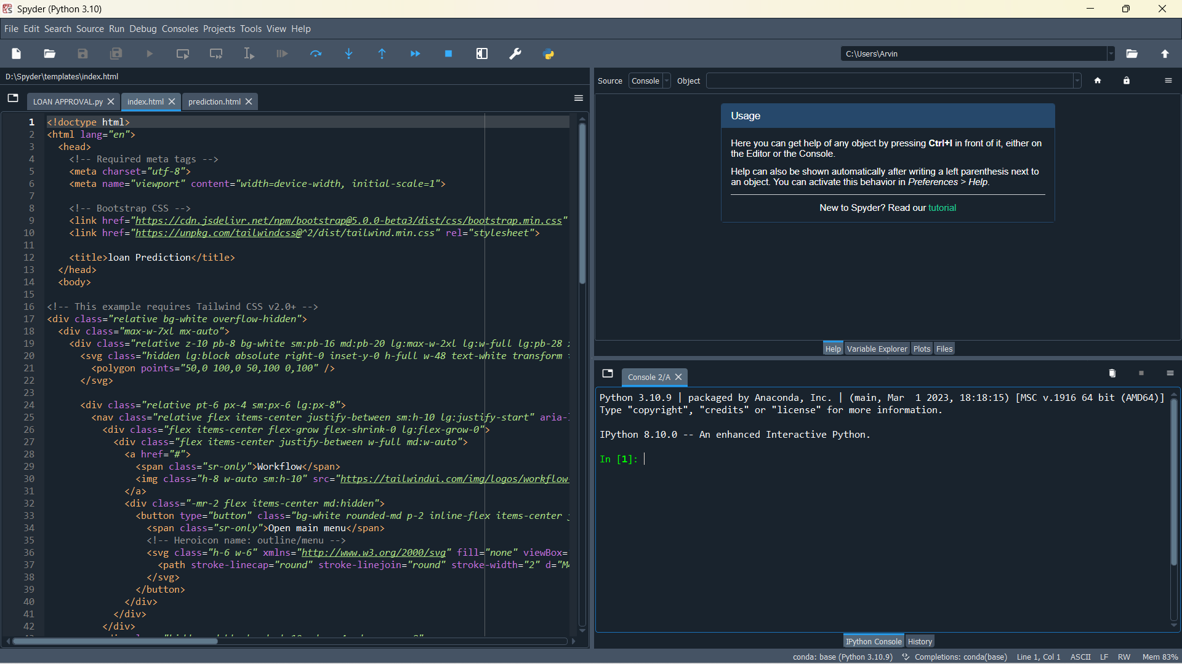

**Index Page**



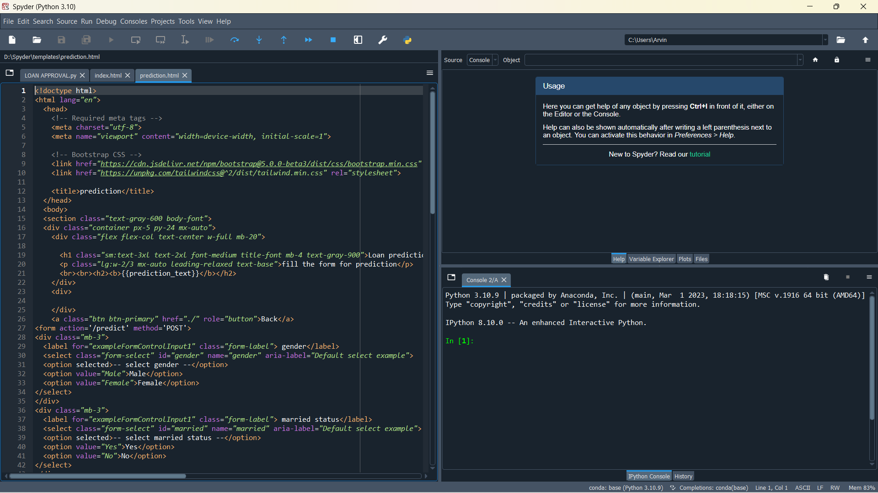

**Prediction Page**

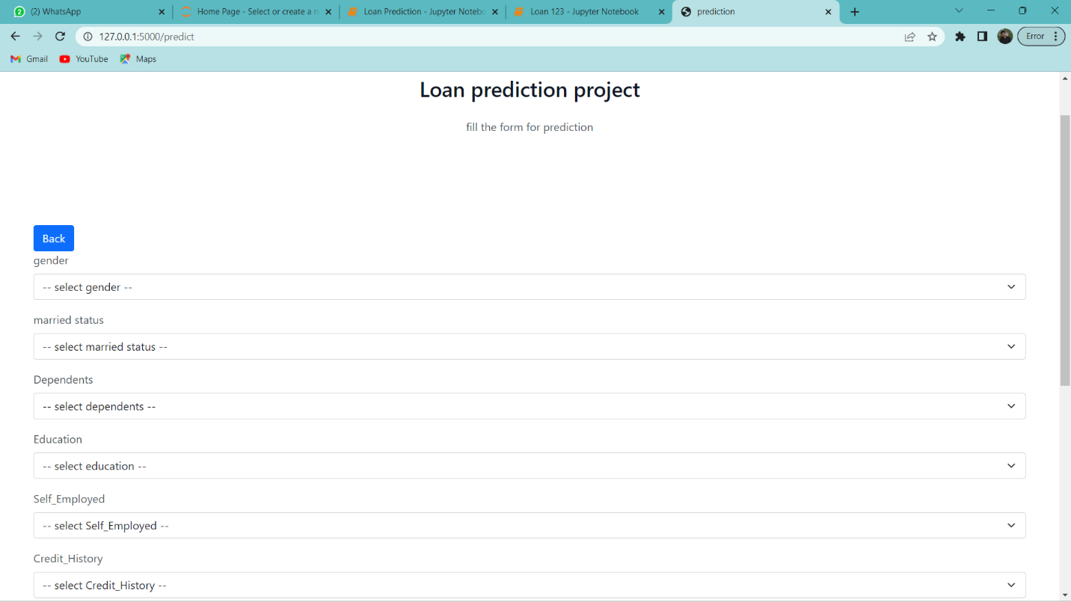

**4. Trailhead Profile Public URL:**

**Team Lead-** [**https://trailblazer.me/id/sskanna**](https://trailblazer.me/id/sskanna)

**Team Member 1-** [**https://trailblazer.me/id/ramev64**](https://trailblazer.me/id/ramev64)

**Team Member 2-** [**https://trailblazer.me/id/ovfftb**](https://trailblazer.me/id/ovfftb)

**Team Member 3-** [**https://trailblazer.me/id/aakash366**](https://trailblazer.me/id/aakash366)

**5. ADVANTAGES & DISADVANTAGES:**

**Advantages:**

* **Increased accuracy: Machine learning algorithms can analyze large amounts of data to identify patterns and make predictions with high accuracy. By using machine learning to predict loan approval outcomes, lenders can make more informed decisions and reduce the risk of errors and biases.**
* **Improved efficiency: Predicting loan approval outcomes using machine learning can automate the loan approval process, reduce the time it takes to make a decision, and improve operational efficiency.**
* **Better risk management: Machine learning models can identify high-risk loan applications that are more likely to default. This can help lenders make informed decisions about whether to approve or deny a loan application, reducing the risk of loan defaults and improving overall risk management.**

**Disadvantages:**

* **Bias: Machine learning algorithms rely on historical data to make predictions, and this data may contain biases that can affect the accuracy of the predictive model. For example, if historical loan data has a bias towards approving loans for certain demographic groups or geographic regions, this could lead to biases in the model and potentially discriminatory outcomes.**
* **Lack of transparency: Machine learning algorithms can be difficult to interpret, especially for non-technical stakeholders. This can make it challenging to understand how the model is making decisions and whether it is making fair and ethical decisions.**
* **Limited understanding of new factors: While machine learning algorithms can identify patterns in historical data, they may struggle to predict outcomes based on factors that have not yet been observed. For example, if there is a sudden economic shock or major regulatory change, a machine learning model may not be able to predict the impact on loan approval outcomes, leading to inaccurate predictions**

**6. APPLICATIONS:**

**Credit risk assessment:**

**One application of the predictive model developed in this project is to assess credit risk. By analyzing applicant data, the model can identify patterns that indicate a borrower's ability to repay a loan. This can help lenders make informed decisions about whether to approve or deny loan applications, reducing the risk of loan defaults.**

**Fraud detection:**

**Machine learning algorithms can be used to detect fraudulent loan applications, which can help prevent financial losses for lenders. The predictive model can analyze data points such as applicant information, employment history, and financial data to identify suspicious patterns or inconsistencies that may indicate fraud.**

**Loan portfolio management:**

**Lenders can use the predictive model to manage their loan portfolio by identifying high-risk loans and adjusting their lending practices accordingly. For example, if the model indicates that loans to a particular industry or geographic region are at high risk of default, lenders can adjust their lending policies or limit the amount of loans they offer in that segment.**

**Personalized loan offerings:**

**The predictive model can be used to personalize loan offerings to individual borrowers. By analyzing applicant data, lenders can offer loan terms and interest rates that are tailored to the borrower's risk profile, financial capacity, and other factors. This can help lenders attract and retain customers while also minimizing their risk.**

**7. CONCLUSION :**

**The project predicting loan approval using machine learning has the potential to significantly improve the loan approval process for both borrowers and lenders. By collecting relevant data on loan applicants and developing an accurate predictive model, lenders can make informed decisions about loan approvals, reduce the risk of loan defaults, and improve operational efficiency. However, it's important to be aware of the potential drawbacks of using machine learning in this context, such as bias, lack of transparency, and limitations in predicting outcomes based on new factors. To mitigate these risks, it's important to use diverse and unbiased training data, ensure transparency and interpretability in the model, and continually monitor and update the model to ensure its accuracy and effectiveness. Overall, the project has the potential to revolutionize the loan approval process and provide borrowers with access to financing more quickly and easily.**

**8 .FUTURE SCOPE:**

**predicting loan approval using machine learning includes expanding to other types of loans, integrating alternative data sources, and integrating with chatbots and other automated tools. Additionally, there is potential to integrate the predictive model with blockchain technology and continually monitor and update the model to ensure its accuracy and effectiveness. These advancements can improve the loan approval process, increase accuracy, and streamline operations for lenders.**

**Integration with blockchain technology:**

**As blockchain technology continues to gain traction in the financial sector, there is potential for integrating the predictive model with blockchain to improve data security and transparency in the loan approval process.**

**Expansion to other types of loans:**

**While the focus of this project is on personal loans, there is potential to expand the predictive model to other types of loans such as business loans or mortgages.**

**Integration with alternative data sources:**

**In addition to traditional data sources such as credit scores and employment history, lenders can explore integrating alternative data sources such as social media data, transactional data, or mobile phone data to improve the accuracy of the predictive model.**

**Integration with chatbots and other automated tools:**

**By integrating the predictive model with chatbots and other automated tools, lenders can streamline the loan application process even further and provide customers with instant feedback on their loan applications.**

**Continual monitoring and updating of the model:**

**As new data becomes available and economic conditions change, it's important to continually monitor and update the predictive model to ensure its accuracy and effectiveness. This can help lenders stay ahead of changing market conditions and improve the overall quality of their loan portfolio.**